A PROJECT REPORT
On
<ANDROID APPLICATION TO FOR TASK MANAGEMENT>
Submitted by
Mr. SALVI ANIL ARUN
in partial fulfillment for the award of the degree
of
BACHELOR OF SCIENCE
in
COMPUTER SCIENCE
under the guidance of
PROF. PRANJALI CHAUDHARI
Department of Computer Science
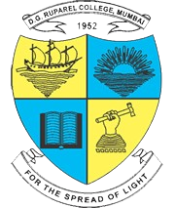
Modern Education Society’s
The D. G. Ruparel College of Arts, Science & Commerce

(Sem - V)
(2026 – 2027)

